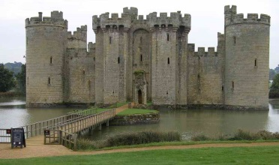
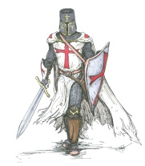
Cedar Class – Spring 2018

Dear Parents,  Happy New Year! This is a brief outline of what we will be studying in Cedar Class this term. Our topic is Knights and Castles. As part of our topic we will be visiting Blacklands Farm. This will take place on Monday 5th February. The children will participate in activities related to being a Knight this will include Archery and Rock Climbing. A letter will be sent home with more information next week. Please encourage your children to play ‘times tables rockstars’ this will help them learn their times tables. Homework will continue to be placed on education city on a Friday and will be due in the following Friday.  Thank you,  Miss Pagden |  | English  Children will improve their research and note-taking skills by finding out about what it means to be a knight. They will write instructions and record the journey of their adventure as a knight. Towards the end of the term, the children will write a letter to persuade the Queen that they should be the one to rescue the damsel. The children will also develop their creative writing skills, writing their own dragon stories.
History- ‘A Knight’s Tale’
History will be based around learning the characteristic features of the medieval period. The children will learn what is required to be a knight and what a knight would have worn. They will learn the skills required being a knight and the daily activities of a knight. We will also study castles, learning the key features and why castles were used.
Maths  The children will continue to extend their knowledge of the four operations. We will then be focusing on measures; this includes looking at perimeter and area. Towards the second half term we will be learning about decimals and fractions. | Science  The two main topics are electricity and forces. The children will start by looking at electricity, making circuits, conductors and insulators. They will make their own game using electricity. Later in the term, they will learn about gravity and air resistance. | Art and DT  We will be making and painting our own shields in an old and modern style. The children will use research to design their own coat of arms.  As part of our topic on Knights we will learn how their history is recorded through tapestries. Our knights will record their  adventure in the same way.
Music  Music will be taught by a music teacher. He will be teaching the children how to play the cornet. You will get a chance to watch this at our class showing assembly. | PSHE  Our first topic is ‘Money Matters’, the children will learn about budgeting, income and outgoings. Our second topic is ‘Who likes chocolate?’ The children will learn about poverty and fairtrade. Also, we will look at how a good knight needs to be chivalrous!
R.E.

We will begin the term by learning about temptations and how they affect our choices, Then, children will learn about the last supper and the crucifixion. After half term, we will looks at stories Jesus told.
Computing
As well as topic related work, children will be learning to write and debug programs that aim to control using bee-bots, lightbot and logo.
PE
Swimming will continue to take place every Tuesday afternoon.
The children will also be learning
Gymnastics with a sports coach.

