Willow Class – Spring 2018

Dear Parents  This is a brief outline of what we will be studying in Willow Class this term as part of our Ancient Greece topic.  Please help your child by discussing the topic with them and supporting them with any homework they receive. If there are any problems I am more than happy to help as well as answer and questions you may have  Mr Clark. |  | Literacy  Children will be researching Greek God’s and Greek Myths which will support them in writing their own Greek Myth. They will also be writing their own modern day twists on popular Greek Myths.  We will also be researching Greece, taking notes and writing a persuasive holiday brochure .
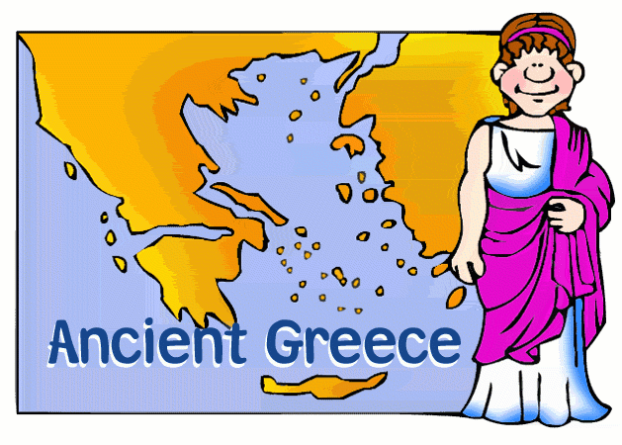

Geography and History
Ancient Greece

Willow class are going to be learning all about Ancient Greece this term. We will be using an atlas to locate Greece and its major cities and landmarks. We will also be using Google Earth to identify the terrain in different parts of the country as well as look at the difference in temperature between the United Kingdom and Greece. We will also be researching the history of Greece, focusing on tradition of men, women and children and the history of the cities of Athens and Sparta will also be studied.

Numeracy  Children will continue to extend their knowledge of the four operations, using standard written methods. They will then be applying their knowledge of these operations to solving real life problems and investigations. Children will also be focusing on fractions, decimals percentages and money during the Spring Term | Science  We will be learning all about the solar system and space during the first half term. During the second half term we will be exploring reproduction, evolution and adaptation followed by the topic of Light | ICT  PowerPoint  Excel  Children will be working on becoming Excel experts during this term. They will learn how to create tables and graphs as well as use formula to create spreadsheets quickly and efficiently.

Music  Children will be working together to prepare for the 2018 Music Festival at The Hawth.  R.E.  We will be reading discussing and producing work based on different creation stories. In the build up to Easter we will also study the Easter story, focusing on telling the story through different viewpoints | PE  Fitness and Multi-skills | Art and DT  Children will be researching and exploring the designs and uses of different Greek pots and vases. Children will then develop their sketching skills by sketching Greek pots and vases .They will then design their own and create it using clay and then finally evaluate their final product.
PSHCE

We will be focusing on careers and money. We will look at choosing different careers and different roles associated with different jobs. We will also focus on investment and savings and the role of charities.

