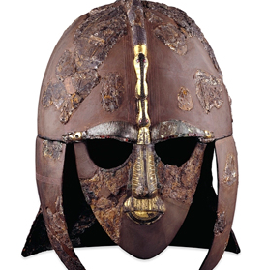
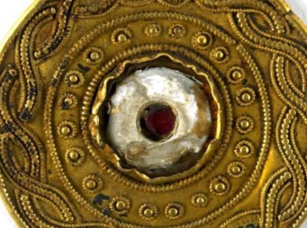

Cedar Class – Autumn 2017

Dear Parents,  This is a brief outline of all the exciting things we will be studying in Cedar Class this term. I hope you find it useful. Our topic this term is the ‘Anglo-Saxons & Vikings’ and much of the teaching this term will link to this topic.  Daily Reading – Please hear your child read as often as possible, recording in their reading records and discuss the books that they have been reading.  Tables – Children are regularly tested on their times tables and given set ones to learn. Please help and encourage your child to learn their tables.  Spellings- The children will be given ten words a week to learn, they will be given out on a Monday and tested the following Monday.  Maths/Topic- This will be set on a Friday and due in the following Friday. This may be a sheet or an online activity.  If you have any queries or would like to speak to me, please feel free to see me at the end of the day.  Thank you,  Miss Pagden |  | History  Anglo-Saxons  Vikings  The children will learn about the Anglo-Saxons in the first half term and then the Vikings in the second half term. The following headings are a brief outline of the aspects we will cover.  Why did the Anglo-Saxons invade?  How did people’s lives change when Christianity came to Britain?  Just how great was Alfred compared to Athelstan?  Why have the Vikings gained such a bad reputation?  How did the Vikings try to take over the country?  Raiders or settlers: How should we remember the Vikings?  They will also cover aspects of Anglo-Saxon and Viking daily life.
English  English will be linked to the Anglo-Saxons and Vikings this term. Through their reading and writing they will not only learn how to improve their writing but also more about Saxon and Viking life. We will cover many genres in English lessons such as: story writing, narrative poetry, newspaper reports, explanation writing and instructions. | Maths  The children will cover the following topics this term.  Place value  Addition and subtraction  Multiplication and division  They will learn and develop these concepts through practical and written activities. The children will also develop their reasoning and problem solving skills.
Science  This will be linked to Anglo-Saxons; we will learn about sound and how it travels. We will also learn about the digestive system. | Music  ‘Classroom Jazz’  ‘Benjamin Britain-A Tragic Story’  Children will listen and respond to a range of music. The will develop their ability to read and play music. Children will also develop their singing voices. | Computing  This term the children will; improve their typing skills, use the internet to search effectively and use a variety of software. The children will also be given an opportunity to develop these skills further in English and History lessons.
Art  Children will use clay to make pots that they will engrave with Runes. We will also look at Saxon art through the study of jewellery and decorated metalwork. The children will be given the opportunity to recreate these patterns using a variety of different techniques. | P.E.  All children in Cedar class will be taught tag rugby with a sports coach on a Friday. Year 4 children will be swimming on a Tuesday whilst year 5 children will be learning about fitness. | R.E.  R.E. this term will focus  on ‘Rights of Passage’ and ‘Advent’ just before Christmas.  .
 | P.S.H..E.  We will cover the following topics this term: ‘It’s Our World’ and ‘Say No!’. | D.T.  Children will learn about food hygiene and preparation as they make and sample historical foods.

