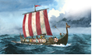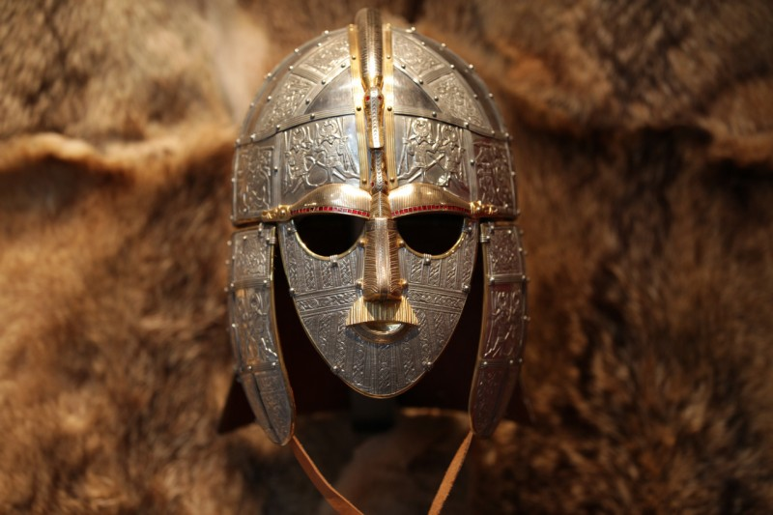

**Viking bread**

**http://minabema.blogspot.co.uk/2009/09/viking-bread-recipe.html**

**Use this website to find the recipe for Viking bread. Make some and bring it in for your friends to taste.**

**Viking poem**

**Create a Poem about a Viking arriving in Ancient Britain.**

**What did they do?**

**How did they feel**

**being so far from**

**home?**

**What were**

**their first**

**impressions of**

**Britain?**

**Place names in the UK**

**Many places were named during Anglo-Saxon times. Can you find out the names of villages, towns and cities which were named during this period?**

**Clue: -ham and –hurst were all Anglo-Saxon words!**

**You could present your findings on a map.**

**Anglo-Saxons and Vikings**

**Autumn 2021**

**Become an archaeologist…**

**You are an archaeologist who has dug up a box of Anglo Saxon artefacts (a bit like Sutton Hoo)**

**What could be inside?**

**Who did the casket belong too?**

**Did they keep a diary?**

**Present your objects in a**

**cask with a diary to show who they**

**belonged to.**

**Viking gods**

**Research a Viking God and make a poster about them. Present your idea in an eye catching way.**

**Art**

**Create your own Sutton Hoo helmet. You can use any materials you would like, look carefully at the detail in the helmet.**

**Viking Culture**

**Create an information page on what life was like in Viking times. Cover the following aspects:**

* **Clothes they wore.**
* **Homes they lived in.**
* **Jobs they did.**
* **Games they played.**

**Anglo-Saxon Maths**

**Create Anglo-Saxon themed multi-step word problems. Think about the four different operations and try and include some from each. You will be able to test your problems out on your friends in maths activities.**

**School trip Maths**

**Cedar class are going to the British museum. Work out how much it would cost the whole class to go to the British museum using the train. Once you have worked this out, plan the rest of the trip. Think about how much money you would need to bring for souvenirs/lunch. Show your costs and plan clearly.**