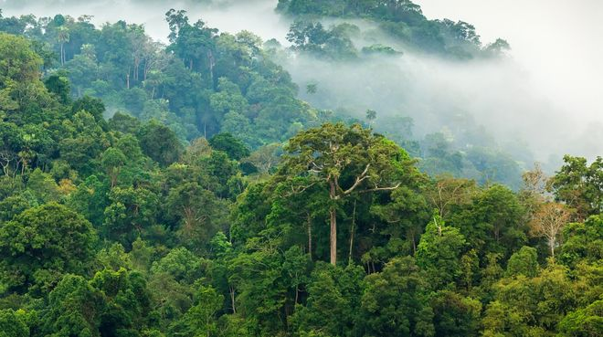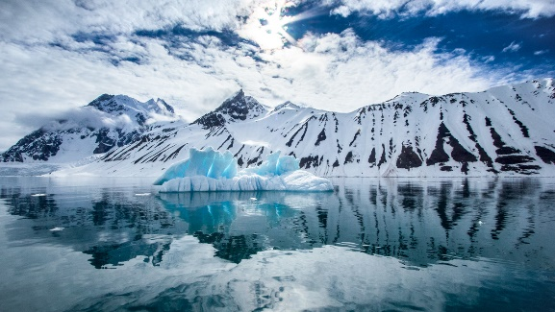

‘What a wonderful world’

Antarctica and the Rainforest

Dear Parents and Carers,

I hope you all had a lovely break. Our topic this term is ‘What a wonderful world – Antarctica and the Rainforest’ We will be learning about Rainforests and Antarctica in detail. We will also be debating the question are we living in a wonderful or worsening world? This will form the theme of our English, Art, DT and Geography lessons. I have attached an optional homework sheet; this contains a variety of different tasks the children may want to complete. It is strongly recommended that the children use spelling shed and times tables rockstars regularly, ideally daily. It is essential that the children learn the spelling patterns and times tables that have been assigned to them, this will also help prepare the children for Willow class and secondary school. Our PE days this term are Wednesday and Friday.

Kind Regards,

Laura Pagden

English

Our English text will be ‘Journey to the River Sea’, we will be using this text in our guided reading sessions. In English we will be writing debates, focusing on environmental issues, we will also be persuading people on ways to help improve the environment. The children will also be writing their own Antarctica and Rainforest poetry. We will also be writing our own stories.

Maths

This term we will be learning about shape, space and measures. The children will be covering statistics, angles and co-ordinates. We will also be covering measures including time and work on multi-step problem solving.

Geography

We will begin by looking at world geography and learning where these places are. The children will use their knowledge of maps, atlases and online programs to improve their place knowledge and world geography. We will learn all about different eco-systems, biomes and vegetation belts. As well as studying physical geography, we will also learn what it is like to live in different places.

Music

The children will be learning the song ‘Make you feel my love’. The children will also be taking part in the summer production.

Science

Science this term will be taught through our topic, we will be learning about living things and their habitats. We will also be learning about animals including humans. There will be a focus on the habitats found in Antarctica and the Rainforest.

\

PE

The children will have PE on a Wednesday with a sports coach, they will also have PE on a Friday. We will be covering Rounders, Athletics and Kwik cricket.

RE

This term we will be learning about food and faith. RE will be taught by Mrs Burton this term.

Art/DT

In art will be looking at sketching different animals and their habitats. We will be using a variety of different materials. We will also be creating our own collages.

PSHE

In PSHE we will be covering the topics ‘dear diary’ and ‘joining in and growing up’. We will also be covering our SRE units this term.