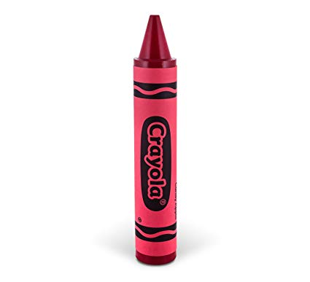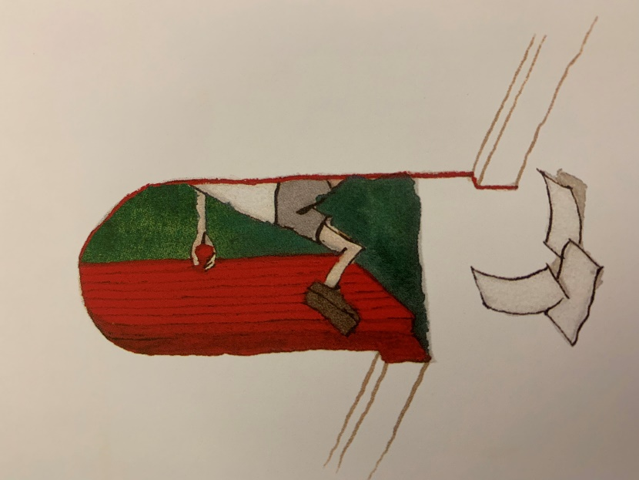

Dear Parents and Carers,

I hope you all had a lovely break. Our topic this term is ‘Through the Door- Colgate Detectives’. This will form the theme of our English, Art, DT, History and Geography lessons. I have attached an optional homework sheet; this contains a variety of different tasks the children may want to complete. This will replace the homework on education city. It is strongly recommended that the children use spelling shed and times tables rockstars regularly, ideally daily. It is essential that the children learn the spelling patterns and times tables that have been assigned to them, this will also help prepare the children for Willow class and secondary school. Our PE days this term are Wednesday and Friday.

Kind Regards,

Laura Pagden

‘Through the Door- Colgate Detectives’



English

In English lessons we will be using extracts from the texts Coraline and Journey. These texts will also be used in our guided reading lessons.

We will be covering a variety of genres this term. These include writing our own through the door stories, postcards, documentary Scripts, Victorian Poetry and instruction writing.

Maths

The children will continue to extend their knowledge of the four operations. We will be focusing on understanding when to use which operation and applying these to multi-step problems. Towards the second half term we will be learning about decimals and fractions. We will then be focusing on measures; this includes looking at perimeter and area.

PE

The children will have PE on a Wednesday with a sports coach, they will also have PE on a Friday.

History and Geography

We will be travelling back in time to find out when our school was built. We will then be looking at Victorian buildings and Victorian schools. In both history and geography, we will study our local area in the past and present. The children will learn what life was like for Victorian children.

Science

The two main topics are electricity and forces. The children will start by looking at electricity, making circuits, conductors and insulators. They will make their own game using electricity. Later in the term, they will learn about gravity and air resistance.

\

Music

The children will be learning the cornet this term. We will also be learning Easter songs.

PSHE

In PSHE we will be covering the topics ‘Living Long, Living Strong’ and ‘Daring to be Different’.

Art/DT

The children will be creating their own life behind the red door pictures. We will be sketching using perspective and studying the artist Henry Moore.

RE

In RE we will cover scriptures, stories Jesus told and Easter. We will be learning what a parable is and creating out own parables.