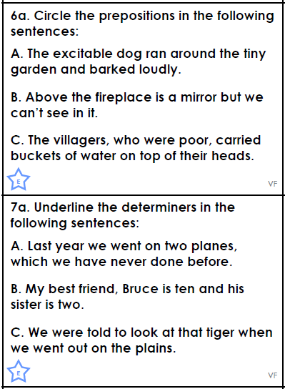
Grammar h/w Determiners & Prepositions
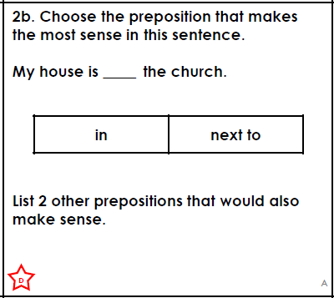

Write a sentence including 2 different determiners and 1 prepositional phrase. Try to use fantastic language as well.
_________________________________________________________________________________________________________________________________________________________________________________________________________________________________

