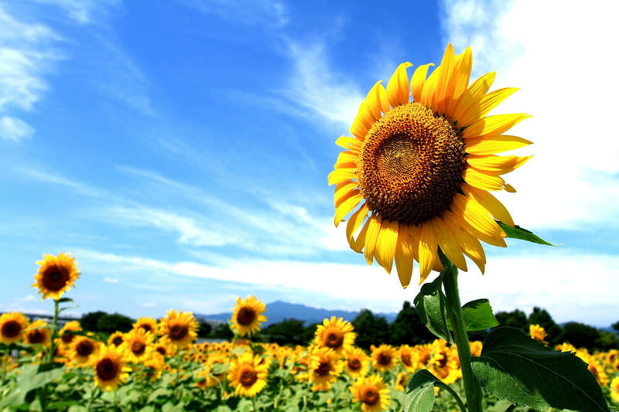
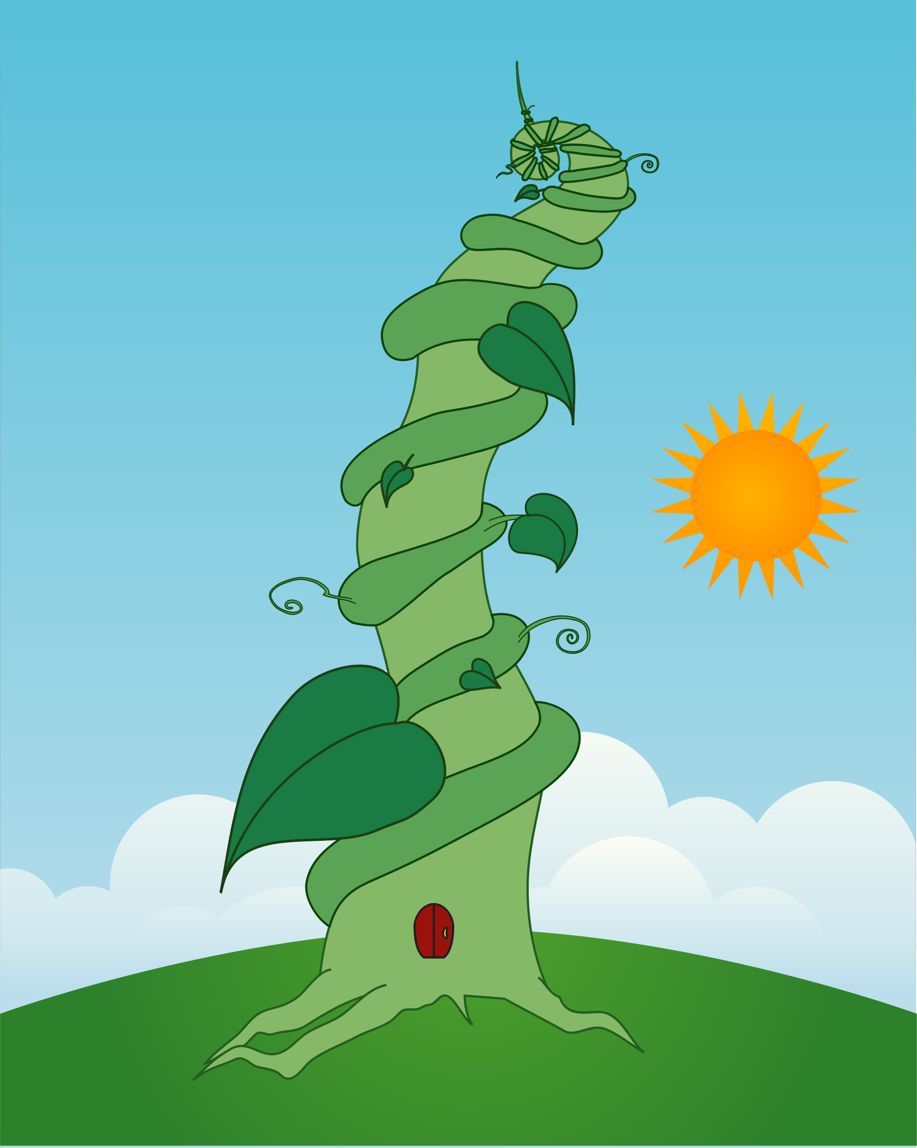

Dear Parents,
We hope you had a great Easter! This is a brief outline of the learning
that will be covered in Maple class this term.

We will be doing PE on Mondays and Wednesdays this term.

Kind regards,
Mrs Forrest and Mrs Hilder
English
We will be reading a range of texts (stories, non-fiction and poetry) relating to plants such as Jack and the beanstalk. We will be writing riddles, stories and reports.
Science  We will be finishing our learning about animals and habitats including life cycles. We will also be learning about the different parts of a plant and the names of a variety of plants as well as learning about what plants need to grow. We will be growing our own beanstalks! | Geography/History  We will be focusing on our local area and use simple fieldwork and observational skills to study the geography of our school and  it’s grounds as well as the key human and physical features. In addition we will be discovering the history of dragons in Colgate! | Maths  Year 1 will continue their learning about measures before moving on to multiplication, division and fractions. Later on the children will revise their knowledge and understanding about time and money.  Year 2 will complete their work on statistics and start a new unit of learning on fractions. After this they will learn about different kinds of measurement (volume, length and height, capacity and temperature)
Music  We will continue to appraise different pieces of music and think about the different instruments we can hear. We will also be learning to play some notes on the xylophone. | PE  We will be developing our throwing, catching, bouncing, kicking and dribbling skills in Games. We will also be playing team games involving attacking and defending. | ICT  Year 1 will learn to add, move and resize images and text and use word banks. Year 2 will be introduced to internet research skills and understand how a web-page displays information in different ways. They will use a web-page to answer questions.
RE  We will be learning about Islam and we will focus on celebrations, special places of worship, journeys and traditions. | Art/DT  In Art, we will be developing our collage skills using plants and flowers as the stimulus.  As part of our DT work, we will be exploring the use of appliqué. | PSHE and RSE  As we return there will be a focus on emotional resilience. We will think about our feelings and others as well as how we can cope with change. Then we will learn about being safe online-discussing what they do online, what information they access, and what to do when they access something upsetting or worrying. We will consider when spending time online becomes unhealthy and why. We will also look at what we should and should not be accessing.

