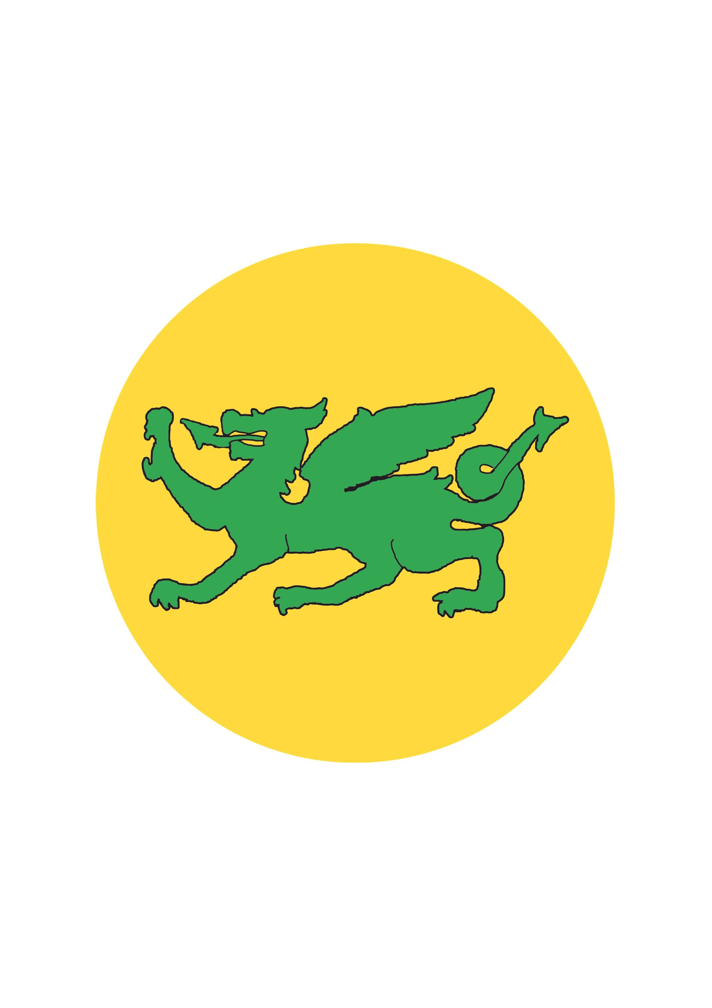
Colgate Primary School PE skills grid

 | EYFS | KS1 |  | Lower KS2 |  | Upper KS2
Thread |  | Year 1 | Year 2 | Year 3 | Year 4 | Year 5 | Year 6
Fundamental Movement Skills | Start to perform fundamental  skills at an emerging level.  Travelling skills  - Running fast  - Hopping on both feet  Sending skills  - Roll a ball underarm  - Underarm throw  - Overarm throw  - Bounce a ball  Receiving skills  - Catch a large ball | Perform fundamental movement skills at a developing level.  Sending skills  - Roll a ball underarm  - Underarm throw  - Overarm throw  - Bounce a ball  Receiving skills  - Catch a large ball | Perform fundamental movement skills at a developing level and start to master basic movements;  Travelling skills  - Running fast Dodging  - Hopping on both feet  - Skipping  - Side galloping  Sending skills  - Roll a ball underarm  - Underarm throw  - Overarm throw  - Bounce a ball  - Strike a ball off a tee  - Strike with a drop feed  Receiving skills  - Catch a large ball | Master fundamental skills and start to develop sport specific skills and perform them with some accuracy. | Cedar Class  Master fundamental  movement skills and start to develop sport specific skills performing them  with consistency and  accuracy. | Continue to develop sport specific skills and perform with consistency, accuracy,  confidence and control. | Continue to develop sport specific skills and perform with consistency, accuracy,  confidence, control and speed.
Maple Class

Travelling skills
- Running fast Hopping on both feet
- Skipping
- Side galloping

Games | Runs skilfully and negotiates space successfully, adjusting  speed or direction to avoid obstacles.  Negotiates space successfully when playing racing and chasing games with other children, adjusting speed or changing direction to avoid obstacles. | To use simple tactics to outwit an opponent.  To throw away from the cones. | To move into space to receive a ball.  To pass a ball to a player in the space.  To throw the ball into space away from the opponent.  To strike the ball away from cones/fielders. | Develop sport specific skills.  Chest pass, bounce pass, swing pass, one handed pass, catching a ball.  To know to move into a space to receive a ball.  To pass to a ball to a player in space when playing an invasion game. | Develop sport specific skills.  To know to move into a space to receive a ball.  To feint or disguise a pass a ball to outwit a defender. | Develop sport specific skills.  Chest pass, bounce pass, swing pass, one handed pass, dribbling a ball, catching a ball, shooting a ball, catching a ball, kicking a ball, (hockey) push pass dribbling, receiving a pass, shooting.  Attacking skills - To use a range of passes.  To pass ahead of supporting players.  To get away from a defender to receive a pass.  Defending skills – to close down space. | Develop sport specific skills.  Chest pass, bounce pass, swing pass, one handed pass, dribbling a ball, catching a ball, shooting a ball, catching a ball, kicking a ball, (hockey) push pass dribbling, receiving a pass, shooting.  Attacking skills - To use a range of passes. To pass ahead of supporting players.  To get away from a defender to receive a pass.  To send the ball wide and/or deep to supporting players.  Defending skills – to close down space. To intercept a pass.
Maple Class

Pretend to throw one way then throw the other.

Look one way and roll the ball the other.

Cedar Class

Chest pass, bounce pass, swing pass, one handed pass, dribbling a ball, catching a ball, shooting a ball.

Dance | Uses movement to express  feelings.  Creates movement in  response to music.  Initiates new combinations  of movement and gesture in order to express and respond to feelings, ideas  and experiences. | Create and link simple combinations of 2 or 3 actions to create a sequence.  Choose appropriate movements for different ideas and repeat short dance phrases. | Create and link simple combinations of 3 or 4 actions to create a sequence.  Link body actions and remember and repeat dance phrases.  Copy and explore basic body actions  TRAVEL, TURN, JUMP, GESTURE, STILLNESS  Vary speed, strength, energy and tension of movements. | Create and perform sequences of actions (4-6) smoothly.  Share and create dance phrases with a partner and in a small group; repeat, remember and perform these phrases in a dance. | Cedar Class  Create and perform sequences of actions (6) with control and precision.  Use simple motifs and movement patterns to structure dance phrases on their own and with a partner. | Create and Perform longer sequences of actions (6-8) with a partner.  Compose motifs and plan dances creatively and collaboratively in groups. | Create and perform longer sequences of actions (8-10) with a partner that show an awareness of their audience.  Work creatively and imaginatively on their own, with a partner and in a group to compose motifs and structure simple dances.
Maple Class

Copy and explore basic body actions.

TRAVEL, TURN, JUMP, GESTURE, STILLNESS

Gymnastics | Moves freely and with pleasure and confidence in a range of ways, such as slithering, shuffling, rolling, crawling, walking, running, jumping, skipping, sliding and hopping.  Mounts stairs, steps or climbing equipment using alternate feet.  Can stand momentarily on one foot when shown.  Jumps off an object and lands appropriately.  Travels with confidence and skill around, under, over and through balancing and climbing equipment. | Create and link simple combinations of 2 or 3 actions to create a sequence.  Shape – Wide, thin  Travelling – feet – jog, skip, gallop, hop, walk forwards, backwards.  Travelling – hands and feet – frog, caterpillar, bunny, crab, bear, crocodile, monkey. | Create and link simple combinations of 3 or 4 actions to create a sequence.  Shape – Wide, thin, dish, arch, tuck  Travelling – feet – jog, skip, gallop, hop, walk forwards, backwards.  Travelling – hands and feet – frog, caterpillar, bunny, crab, bear, crocodile, monkey  Balancing – front support, balance on 4 & 3 points, large body parts – tummy, back, bottom, shoulders.  Jumping and landing  Rolling – rock and roll, pencil, egg roll, dish roll, teddy roll, forward roll.  Apparatus work. | Create and perform sequences of actions (4-6) smoothly.  Travelling – feet – jog, skip, gallop, hop, walk forwards, backwards.  Travelling – hands and feet – frog, caterpillar, bunny, crab, bear, crocodile, monkey.  Balancing – small body parts – one-foot balance, arabesque, square bridge, bridge, hands and feet.  Jumps – Straight, straddle, pike, tuck  Rolling – rock and roll, pencil, egg roll, dish roll, teddy roll, forward roll.  Apparatus work. | Create and perform sequences of actions (6) with control and precision.  Travelling – feet – jog, skip, gallop, hop, walk forwards, backwards, side gallop, walk on tiptoes.  Travelling – hands and feet – frog, caterpillar, bunny, crab, bear, crocodile, monkey. | Create and Perform longer sequences of actions (6-8) with a partner.  Travelling – feet – jog, skip, gallop, hop, walk forwards, backwards, chasse.  Travelling – hands and feet – frog, caterpillar, bunny, crab, bear, crocodile, monkey.  Balancing – small body parts – one-foot balance, arabesque, square bridge, bridge, front support, back support, hands and feet. Large body parts – V sit, dish, arch, shoulder stand.  Balance with a partner – counter balance, counter tension.  Jumps – Straight, straddle, pike, tuck, 1/2 turn, full turn.  Rolling – rock and roll, pencil, egg roll, dish roll, teddy roll, forward roll. | Create and perform longer sequences of actions (8-10) with a partner that show an awareness of their audience.  Travelling – feet – jog, skip, gallop, hop, walk forwards, backwards, chasse.  Travelling – hands and feet – frog, caterpillar, bunny, crab, bear, crocodile, monkey.  Balancing – small body parts – one-foot balance, arabesque, square bridge, bridge, front support, back support, hands and feet. Large body parts – V sit, dish, arch, shoulder stand.  Balance with a partner and small group – counter balance, counter tension.  Jumps – Straight, straddle, pike, tuck, 1/2 turn, full turn .  Rolling – rock and roll, pencil, egg roll, dish roll, teddy roll, forward roll.
Maple Class

Balancing – front support, balance on 4 & 3 points, large body parts – tummy, back, bottom, shoulders.

Jumping and landing – 2 to 2 for height.

Rolling – rock and roll, pencil, egg roll.

Apparatus work.

Cedar Class

Balancing – small body parts – one-foot balance, arabesque, square bridge, bridge, front support, back support, hands and feet. Large body parts – V sit, dish, arch, shoulder stand.

Jumps – Straight, straddle, pike, tuck, 1/2 turn, full turn

Rolling – rock and roll, pencil, egg roll, dish roll, teddy roll, forward roll.

Outdoor and adventurous |  |  |  | Orientate a map.  Use a control card.  Navigate a course safely. | Travel and balance safely when carrying out challenges.  Demonstrate team work skills during planning, doing and reviewing. | Know how to keep the map set or orientates when they move around a simple course.  Know the eight points of a compass.  Record information accurately at the control marker.  Navigate to a control marker on a score event course. | To set a map using a compass.  To practice and refine thumbing the set map (orientated)  To set a direction of travel from the map, using a compass.  To follow instructions in order to complete an orienteering course.
Striking and Fielding |  | Strike a ball off a tee.  Look for space to throw, hit or run into help team score.  Understand why they need to throw or hit into space.  Use a feint to try and win a game. | Strike a ball off a tee  Strike with a drop feed  Look for space to throw, hit or run into help team score.  Understand why they need to throw or hit into space.  Understand the concept of aiming and the need for accuracy.  Throw or hit an object into a space to make it more difficult for their opponents.  Use a feint to try and win a game. | Bowl underarm.  Strike a ball off a tee.  Catch a ball.  Field a ball and return it quickly. | Bowl underarm.  Catch a ball.  Field a ball and return it quickly. | Bowl underarm.  Strike a ball off a tee.  Strike bowled bowl.  Field a ball and throw back overarm. | Bowl overarm.  Strike a bowled ball.  Field a ball and throw back overarm.
Cedar Class

Perform a straight drive.
Net and Wall |  | Look for space to throw, hit or run into help team score.  Understand why they need to throw or hit into space. | Look for space to throw, hit or run into help tem score.  Understand why they need to throw or hit into space.  Understand the concept of aiming and the need for accuracy.  Throw or hit an object into a space to make it more difficult for their opponents.  Use a feint to try and win a game. | Ready Position.  Underarm throw.  Overarm throw.  Hold a racket.  Strike a ball with a racket. | Ready Position.  Underarm throw.  Overarm throw.  Hold a racket.  Strike a ball with a racket. | Throwing a ball.  Hold a racket correctly.  Forehand.  Backhand.  Volley. | Throwing a ball.  Forehand.  Backhand.  Volley.  Underarm serve.
Maple Class

Use a feint to try and win a game.

Athletics | Start to perform fundamental skills at an emerging level.  Travelling skills-  Running fast  Sending skills – Roll a ball underarm throw  Overarm throw  Runs skilfully and negotiates space successfully, adjusting speed or direction to avoid obstacles.  Negotiates space successfully when playing racing and chasing games with other children, adjusting speed or changing direction to avoid obstacles. | Perform FMS at a developing level.  Running  Hopping  Rolling a ball  Underarm throw  Jumping | Perform FMS at a developing level and start to master some basic skills.  Running  Underarm throw  Overarm throw  Push throw  Jumping for distance. | Master FMS skills and start to develop athletic specific skills performing them with consistency and accuracy.  Throwing – push, pull and sling  Hop, step and jump. | Master FMS skills and start to develop athletic specific skills performing them with consistency and accuracy.  Throwing – push, pull and sling.  Hop, step and jump. | Continue to develop athletic specific skills and perform them with consistency, accuracy, confidence, control and speed.  Throwing – push, pull, sling, heave  Jumping – standing long jump and triple jump.  Running short and long distance.  Passing a baton in a relay. | Continue to develop athletic specific skills and perform them with consistency, accuracy, confidence, control and speed.  Throwing – push, pull, sling, heave  Jumping – standing long jump and triple jump.  Running short and long distance.  Passing a baton in a relay
Swimming |  |  |  |  | Oak Class  Children will learn how to swim between 10-20 metres unaided in shallow water, using their arms and legs to propel themselves.  They will use one basic method to swim the distance, making sure they breathe.  They will start by using floats, swim over longer distances and periods of time with a more controlled leg kick.  They will explore freely how to move in and under water, recognise the affects their temperature and identify and describe the difference between leg and arm actions.

