Dear Parents,

I hope you all had a lovely summer break, below is the outline of the topics that we are going to cover over this term. Our topic theme is ‘The Ancient Mayans and The History of Chocolate.’

Trip

There will be a trip to The British Museum in London, this will take place on Monday 19th November 2018.

Seesaw

We will continue to use seesaw this year, you should have received a sign-up email from Mrs Oakes. The email contains information showing you how to sign up to your child’s new class.

Times Tables Rockstars

The children should be using ‘times tables rockstars’ regularly. It is really important they are now fluent with their times tables, as they need to apply this learning to other areas of maths.

Homework

Homework is optional and will be uploaded to Education City regularly. This may be either English, Maths or Science.

Parent Readers

We would appreciate any parent/carers who would be able to come in and listen to readers. Please let myself of Mrs Oakes know if you are able to help.

Kind Regards,

Laura Pagden

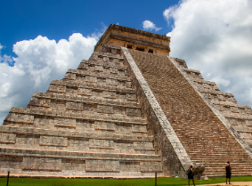
The Ancient Mayans and The History of Chocolate
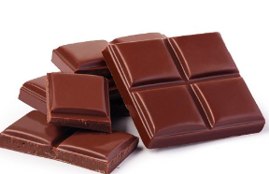
Autumn 2018
RE
This term in RE we will focus on ‘life is a journey’ and ‘justice and equality’.
PSHE
Our topics for this term are ‘We’re All Stars’ and
‘Be Friendly, Be Wise’.

ICT/Computing
We will be using crazy talk, creating web pages. Learning about internet safety and using the internet. We will also develop our word skills and use green screen.
PE
The children will be learning be learning hockey and dance this term. Dance lessons will be based around traditional Mayan dance.
Maths

The children will cover the following topics this term.
Place value
Addition and subtraction
Multiplication and division

They will learn and develop these concepts through practical and written activities. The children will also develop their reasoning and problem-solving skills.
History/Geography
Our focus this term is ‘The Ancient Mayans and The History of Chocolate’. We will begin by working out who the Mayans were, where they were located and why they were important. We will learn about Mayan culture- including Mayan gods. After half term, we will move on to understanding how the Mayans discovered chocolate, we will then look at the history of chocolate. In geography, we will look at where chocolate originates and how chocolate is different around the world. We will also learn about fair trade and the impact this has on countries and people.
Art
We will be learning about Mayan murals and hieroglyphics. We will also create our own pottery.

Music
We will be learning ‘Five Gold Rings’ and ‘Don’t Stop Believin’.

English
In English we will write letters critiquing films, we will design web pages informing other children about Mayan culture. The children will spend time creating their own gods and writing stories about them. We will also create our own chocolate poems, explanation texts of how chocolate is made and persuasive texts based on chocolate.
DT
We will be making and cooking our own tortillas and experimenting with chocolate.

Science
This will be linked to the Ancient Mayans; we will learn about sound and how it travels. We will also learn about the digestive system.

