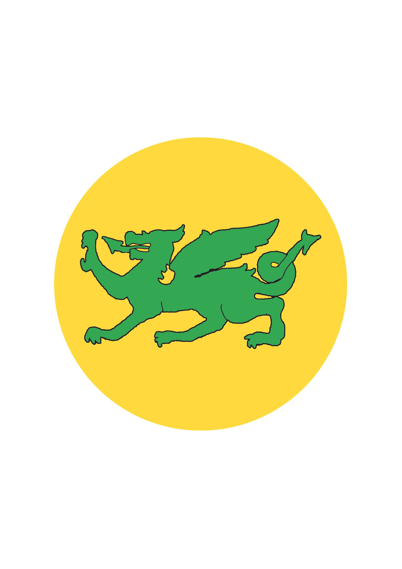
Colgate Primary School Geography skills grid
Bold- National Curriculum Requirements
 | EYFS | KS1 |  | Lower KS2 |  | Upper KS2
Thread |  | Year 1 | Year 2 | Year 3 | Year 4 | Year 5 | Year 6
Locational and Place knowledge | Name and locate different parts of the local community. | Name and locate some places in their locality, the UK and wider world. | Name and locate significant places in their locality, the UK and wider world. | Name and locate a wider range of places in their locality, the UK and wider world. | Name and locate a wider range of places in their locality, the UK and wider world including some globally significant features. | Name and locate an increasing range of places in the world including globally and topically significant features and events. | Name and locate an extensive range of places in the world including globally and topically significant features and events.
Maple Class

Learn names of some places within/around the UK. E.g. Home town, cities, countries e.g. Wales, France.

Human and Physical Geography | Use the local area for exploring both the built and the natural environment.  Express their opinions on natural and built environments. | Describe some places and features using basic geographical vocabulary.  Express their views on some features of their environment e.g. what they do or do not like. | Describe places and features using simple geographical vocabulary.  Make observations about features that give places their character. | Use geographical language to describe some aspects of human and physical features and patterns.  Make observations about places and features that change over time. | Use geographical language to identify and explain some aspects of human and physical features and patterns. | Use geographical language to identify and explain key aspects of human and physical features and patterns as well as links and interactions between people, places and environments.  Demonstrate understanding of how and why some features or places are similar or different and how and why they change. | Recognise patterns in human and physical features and understand some of the conditions, processes or changes which influence these patterns.  Explain some links and interactions between people, places and environments.
Cedar Class

Describe how features and places change and the links between people and environments.
Geographical Fieldwork and Investigation | Comment and ask questions about aspects of their familiar world such as the place where they live or the natural world.  Show care and concern for living things and the environment.  Find out about the environment by talking to people, examining photographs, simple maps and visiting local places. | Ask and answer simple geographical questions.  Describe some similarities and differences when studying places and features e.g. hot and cold places of the world.  Observe and describe daily weather patterns. | Ask and answer simple geographical questions when investigating different places and environments.  Describe similarities, differences and patterns e.g. comparing their lives with those of children in other places and environments.  Identify seasonal and daily weather patterns.  Develop simple fieldwork and observational skills when studying the geography of their school and local environment. | Ask and answer more searching geographical questions when investigating different places and environments.  Identify similarities, differences and patterns when comparing places and features.  Observe, record, and name geographical features in their local environments. | Identify and describe similarities, differences and patterns when investigating different places, environments and people.  Observe, record, and explain physical and human features of the environment. | Ask and respond to questions that are more causal e.g. Why is that happening in that place? Could it happen here?  Recognise geographical issues affecting people in different places and environments.  Observe, measure, and record human and physical features using a range of methods e.g. sketch maps, plans, graphs, and digital technologies. | Ask and respond to questions that are more causal e.g. What happened in the past to cause that? How is it likely to change in the future?  Make predictions and test simple hypotheses about people, places and geographical issues.  Use a range of numerical and quantitative skills to analyse, interpret and present data collected from fieldwork observations, measurements and recordings.
Cedar Class

Ask and respond to more searching geographical questions including ‘how?’ and ‘why?’

Maple Class

Use simple fieldwork and observational skills when studying the geography of their school and its grounds.

Interpreting and communicating with geographical sources | Use a range of sources such as simple maps, photographs, magnifiers. and visiting local places.  Use a range of sources such as simple maps, photographs, magnifiers. and visiting local places. | Use a range of sources such as simple maps, globes, atlases and images.  Know that symbols mean something on maps.  Use maps and other images to talk about everyday life e.g. where they live, journeys to school etc.  Draw, speak or write about simple geographical concepts such as what they can see where. | Use a range of sources such as maps, globes, atlases and aerial photos to identify features and places as well as to follow routes.  Use simple compass directions as well as locational and directional language when describing features and routes.  Express views about the environment and can recognise how people sometimes affect the environment.  Create their own simple maps and symbols. | Use a range of sources including digital maps, atlases, globes and satellite images to research and present geographical information.  Express their opinions on environmental issues and recognise how people can affect the environment both positively and negatively.  Communicate geographical information through a range of methods including the use of ICT. | Express their opinions on environmental issues and recognise that other people may think differently.  Communicate geographical information through a range of methods including digital maps, plans, graphs and presentations. | Use a range of maps and other sources of geographical information and select the most appropriate for a task.  Demonstrate an understanding of the difference between Ordnance Survey and other maps and when it is most appropriate to use each.  Express and explain their opinions on geographical and environmental issues and recognise why other people may think differently.  Choose from a range of methods e.g. digital maps, plans, graphs and presentations when communicating geographical information. | Interpret a wider range of geographical information and maps including scale, projections, thematic, and digital maps.  Recognise an increasing range of Ordnance Survey symbols on maps and locate features using six-figure grid references.  Develop their views and attitudes to critically evaluate responses to local geographical issues or global issues and events.  Communicate geographical information using a wide range of methods including writing at increasing length.
Cedar Class

Use a range of sources including digital and Ordnance Survey maps, atlases, globes and satellite images to research geographical information.

Map Work | Follow simple directions.  Draw and create their own maps using real objects, and/or pictures and symbols.  Look at signs and symbols on different types of maps for example in school, and the local community.  Use a simple map with symbols to spot features in the school grounds or in the local community.  To see real maps, electronic globes and maps, maps of the classroom/school, local town, park, zoo, museum etc, story maps. | Use picture maps and globes.  Draw picture maps of imaginary places and from stories.  Use own symbols on imaginary map. | Follow directions (as yr 1 but now including North South East West)  Draw a map of a real or imaginary place. (e.g. add detail to a sketch map from aerial photograph)  Begin to understand the need for a key.  Use class agreed symbols to make a simple key.  Follow a route on a map.  Use a plan view.  Use an infant atlas to locate places/begin to use google earth.  Find land/sea on globe.  Use teacher drawn base maps.  Use large scale OS maps.  Locate and name on UK map major features e.g. London, River Thames, home location, seas. | Use 4 compass points to follow/give directions:  Use letter/no. coordinates to locate features on a map.  Know why a key is needed.  Use standard symbols.  Locate places on larger scale maps e.g. map of Europe.  Follow a route on a map with some accuracy. (e.g. whilst orienteering)  Use large scale OS maps.  Begin to use map sites on internet.  Begin to use junior atlases/google earth/ google maps.  Begin to identify features on aerial/oblique photographs. | Use 4 compass points well: Begin to use 8 compass points;  Use letter/no. coordinates to locate features on a map confidently.  Know why a key is needed.  Locate places on large scale maps, (e.g. Find UK or India on globe)  Follow a route on a large scale map. | Use 8 compass points.  Begin to use 4 figure coordinates to locate features on a map.  Compare maps with aerial photographs.  Select a map for a specific purpose. (E.g. Pick atlas to find Taiwan, OS map to find local village.)  Begin to use atlases to find out about other features of places. (e.g. find wettest part of the world)  Use index and contents page within atlases.  Use medium scale land ranger OS maps.  Draw a sketch map using symbols and a key;  Use/recognise OS map symbols.  Confidently use google earth/google maps. | Use 8 compass points confidently and accurately;  Use 4 figure co-ordinates confidently to locate features on a map.  Begin to use 6 figure grid refs; use latitude and longitude on atlas maps. (Online included)  Describe features shown on OS map and follow a route.  Locate places on a world map.  Use atlases to find out about other features of places. (e.g. mountain regions, weather patterns)  Draw a variety of thematic maps based on their own data.  Begin to draw plans of increasing complexity  Use OS maps.  Confidently use an atlas.  Recognise world map as a flattened globe.
Maple Class

Follow directions (Up, down, left/right, forwards/backwards)
Use a simple picture map to move around the school; recognise that it is about a place.

Cedar Class

Begin to recognise symbols on an OS map.

Make a map of a short route experienced, with features in correct order;

Make a simple scale drawing.

Use large and medium scale OS maps.

Use junior atlases. Use map sites on internet, such as google earth and maps.

Identify features on aerial/oblique photographs.

