Willow Class - Autumn Term 2017
Reach For The Sky  Dear Parents/Guardians/Carers  Over the Autumn term Willow Class will be working on the topic "Reach For The Sky". In these topics we look at different mountain ranges from around the world using our geographical skills. Much of the work we will do in English, science, design technology, ICT, PSHCE, geography and art will be linked to this exciting topic.  The children will also be taking part in Forest Schools during this term. This will give the children the opportunity to learn outdoor survival skills including making a shelter, lighting a fire and adapting to different situations outdoors.  If you have any queries or would like to discuss anything with me, please let me know and we will arrange to meet at a time convenient to both of us.  Regards  Mr Clark |  | Literacy  Our literacy work will focus on two texts: Touching the Void and Blue John. From our work on Touching the Void we aim to write; a description, a diary extract, a set of instructions and a report.  With Blue John we will be writing an extended fantasy story based on what we have been reading.  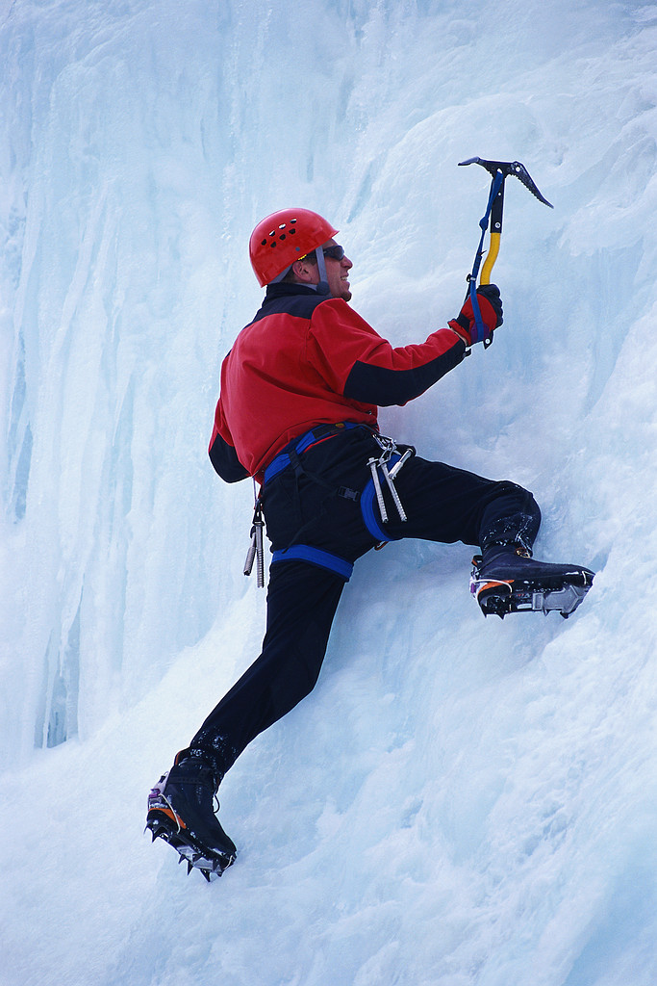  Our class readers will be, King of The Cloud Forest by Michael Morpurgo and Cliff Hanger by Jacqueline Wilson.
Maths  The children will begin the year working on place value before applying this knowledge to standard written methods for multiplication and division with whole numbers and decimal numbers. We will also begin solving problems involving, fractions & percentages | Science  The children  will be learning about friction, changing states and dissolving.   | Religious Education  During this term we will be looking at stories from the Old Testament as well as studying the structure of the Bible..  
 | French  French lessons will continue to develop confidence with spoken French focusing on vocabulary and expression. | Geography  We will be learning about mountains, their formation, location, life in the mountains and the effect of human developments on the mountain environment.
ICT  Part of our ICT work will involve using the internet to research information about web sites, mountaineering and mountains. We aim to produce a website using Power Point to show all of our learning in this topic.  We also aim to animate part of our fantasy writing based on Blue john using Crazy Talk. | PE  Willow class will have PE on a Monday and Thursday.  PE session 1: netball followed by Outdoor Adventure Activities.  PE session 2: Cross country and fitness  Children will be taking part in outdoor PE in all weathers and should come to school suitably prepared. | Music  Year 5 and 6 children will be working with Soundmakers to learn the Cornet on a Thursday morning. Children will be working towards performing a concert at the end of the term.  
Design Technology  The children will be designing and making a shelter suitable for an animal in our school environment.  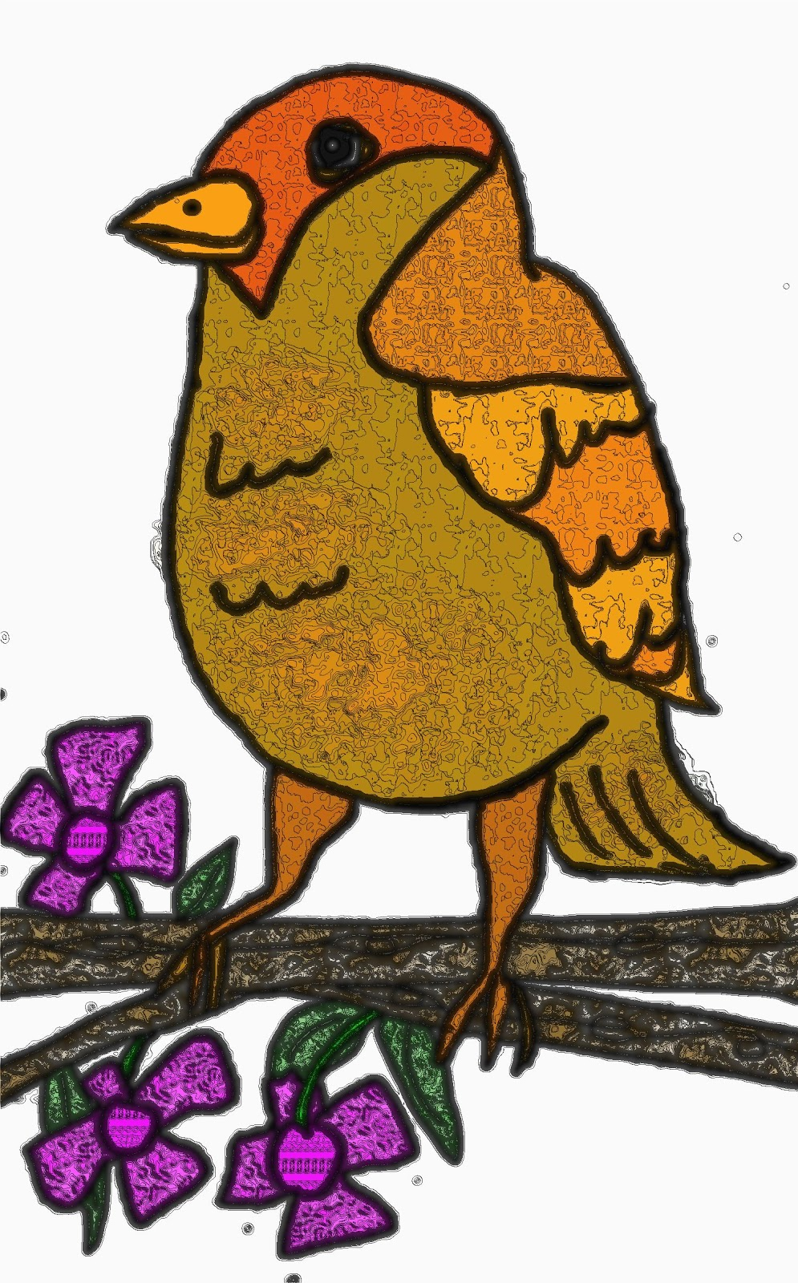 | Art  We will be focusing on landscapes and will initially create pictures based on the story, Blue John. We will then recreate these designs on silk.  The final piece will then be used to create a CD cover for our story recording. | PSHCE  We will be developing our personal and social skills through focusing on the issues surrounding democracy, bullying and peer mediation.
Forest Schools
You will receive a letter about Forest School and the clothing your child will need to bring to be suitably prepared. Forest Schools will take place on Tuesday afternoons during this term

Homework
Maths Homework- Weekly, handed out on a Tuesday and due in the following Tuesday. This homework will be set on Education City
Literacy /topic – This will range from mini projects set over 2-3 weeks to a one off weekly homework focusing on grammar activities
Reading- Read for 20 minutes at least 3 times per week
Tables & Spelling- We practise at school but some extra practice at home is expected. Children will be given ten spellings every Monday based on different spelling patterns and words in the Year 5 and 6 curriculum. There will be a spelling quiz every Friday

