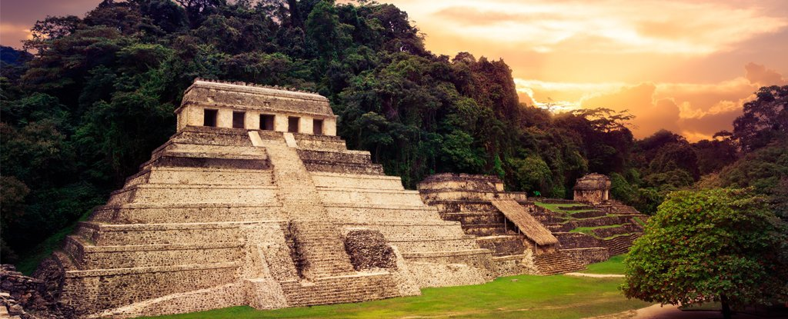

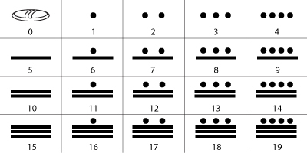

Use the Mayan number system to create your own arithmetic questions.

Can you create your own Mayan maths word problems?

We will be having a maths lesson, where we can swap and solve each other’s.

The Mayans were great farmers and enjoyed eating tortillas filled with cooked vegetables! Can you design your own Mayan tortilla recipe?

The Mayan’s loved chocolate. Can you find out about how chocolate is made? Draw a flow chart to show the process of making chocolate. You could use pictures and diagrams to help.

Can you find out about the different Mayan gods? Can you draw a picture of what you think they looked like? Write about what you have found out.

Where in the world did the Mayans live? Use a map to find out! Can you plot the different Mayan cities on the map?

Can you draw or make a Mayan temple? Write about why the temples were so important to the Mayans.

**Mayan**

**Homework**

Can you write your own Mayan myth? What kind of characters will you include? Write, type or video your myth!

Can you find out about the Mayan calendar? What was it? Write about what you find out.

Think about your favourite chocolate treat? Design a wrapper for a new chocolate bar you have invented or design a video advert to advertise your product.

Can you design and create your own Mayan headdress? Write a paragraph about why they wore them.