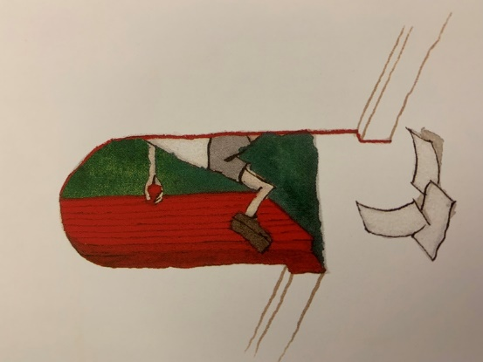

Victorian children

Create a poster explaining what life was like for Victorian children at home and school.

Victorian School

Draw a detailed picture of a Victorian school. Label this diagram.

Perspective Art

Create a perspective sketch of your own house. Remember to include the red door!

Victorian School

Design an activity sheet including the activities Victorian children would have completed.

Maps

Use google maps/earth to find your house. Look around your house.

Create your own map showing what the land around your house is used for.

Are there churches, open fields, railway stations, other homes, rivers or ponds?

Dear Cedar Class,

This homework sheet is to replace education city and the activities are optional. However, there will be rewards for completing the activities below. I suggest you choose one to complete every two weeks, you can then bring your activities into school. Make sure you read every day and play times tables rockstars/spelling shed regularly. You get new spellings every two weeks.

Miss Pagden

Schools in the Past

Ask a relative to tell you what life was like when they were at school. Jot down some notes and bring these into school. We can then compare what was similar and what was different.

Or you can record your interview and upload it to seesaw.

Have any of you relatives got any old school photos? If they do and don’t mind bring them into school.

Game

Create a board game for Victorian children. This board game needs to help children learn their times tables, make sure your game includes instructions on how to play.

Art

In art we will be learning about the artist Henry Moore. Create a fact file on Henry Moore.

‘Through the Door- Colgate Detectives’

Film Review

Create a film review of Coraline.

Remember a film review includes the following things;

* What was good about the film?
* What could be improved?
* Who and what ages would you recommend it to?

Detective Maths

Create twelve Colgate detective themed maths problems. Remember to include an answer sheet, we will have time to solve these in class. Make sure they are challenging, try and include two step problems.

Victorian Buildings

Create a fact file on Victorian buildings. Think about what was inside the building as well as the outside.