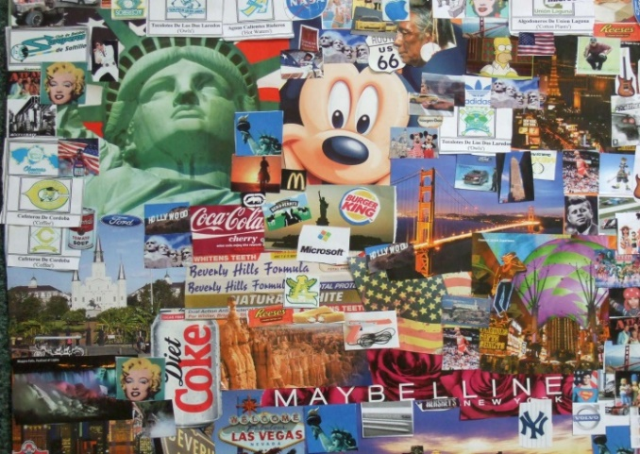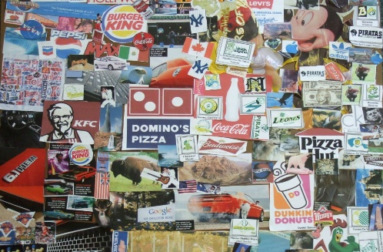

Around the World in 80 Days

Plan and write a story that includes travelling around the world. Think carefully about your plan, slowly introduce your setting and characters. Remember to build tension.

Natural Disasters

Choose a natural disaster, explain what caused the natural disaster. Identify the impacts of the natural disaster, remember to include lots of facts. It could be a volcanic eruption, earthquake or maybe a tsunami.

**Around the world in**

**80 days.**



Can you persuade Miss Pagden to live in your favourite country?

Where in the world would you like to live? Your challenge is to write a letter to persuade Miss Pagden that your chosen country is the best place in the world to live. Use the techniques we learnt in class.

Creating a Collage

Choose a country that interests you and create a collage of that country. What do you think of when you think about that country? Include pictures of tourist attractions, brand logos, places to visit, traditions etc.

Interview a family member or friend

Interview a family member or friend who has visited another country. What did they like or not like about that country? What did they do when they were there?

You can present this information however you would like. It could be video, voice recording, pictures or written questions and answers.

Travel Agent- Maths

Your challenge is to work out how much a holiday to a country you would like to visit would cost. (7 day holiday)

Remember to include the price of the flight, hotel, attractions and food. Tell me who you would fly with, where you would stay and what attractions you will visit.

Animals around the World

Choose a continent or country and find out information on the different animals that live there. For example, what animals are there in Africa? Why are these animals found in Africa?

www.activewild.com/animals

Investigating a country

Choose a country you don’t know a lot about. Identify the natural and man-made features and why they would make somebody want to visit. You can present this information however you would like. You might present it as a labelled picture or an information page.

Where have I visited?

Choose a city or country you have visited. Create a poster showing what you did when you were there and why you liked it. You can include photographs and drawings.

Famous Explorers

Choose a famous explorer (not Shackleton). Tell me all about the explorer, you can present your information in any way you like. It could be a video, a poster or a picture.

Favourite Places in the World

Choose your favourite country or place in the world. Create a fact file on that country/place. (It could be your home town but remember to explain which country it is in.)

Favourite Places in the World

Sketch a picture of your favourite place in this country or in the world. Write a sentence explaining why it is your favourite place.